WCCI CEC 2026 HDMMO Competition Entry Instruction Document

1. NSGA-II Operational Example

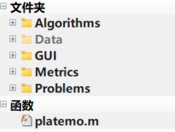
1. Run platemo.m file

2. Click on the Experiment Module

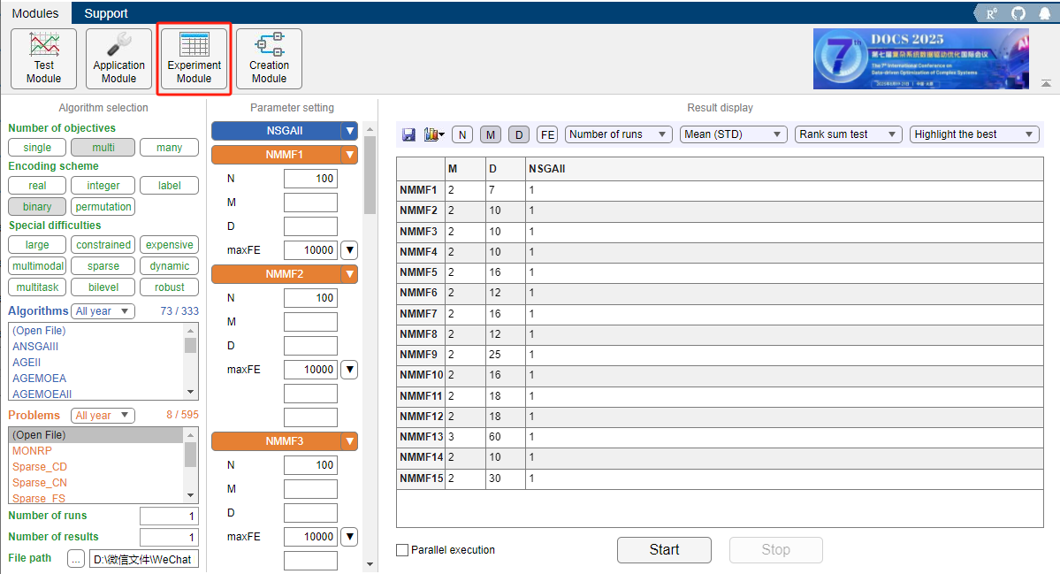

Select the multimodal type
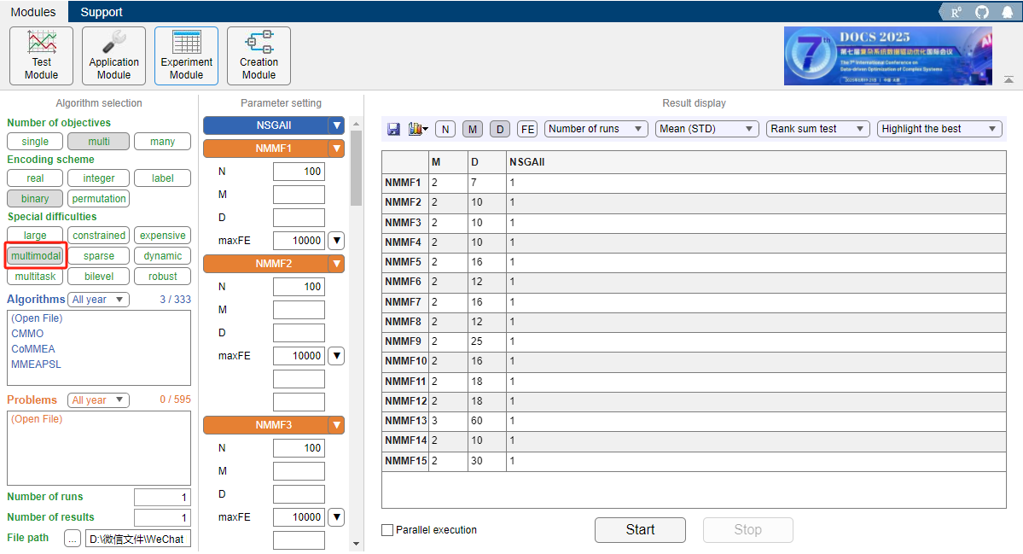4. Sequentially add competition problems NMMF1-NMMF15, adjust the population size N, and evaluation count maxFE according to the competition requirements (The decision variable dimension D of the decision variables in the test functions ranges from 7 to 60. The population size N is set to 100, and the maximum evaluation count maxFE for each test function is set to 200,000). Then, modify the number of runs to 31 and click 'Start.
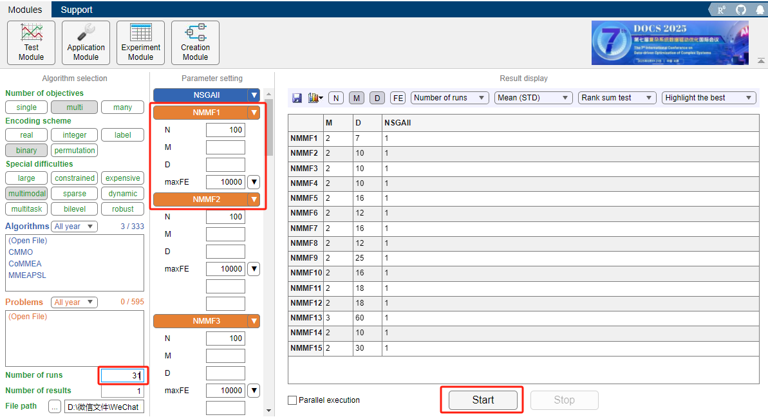
3
2
1

2. Add your own algorithm to the platemo platform
Refer to the manual file

